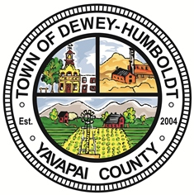
PUBLIC NOTICE
Town of Dewey-Humboldt
2735 S Highway 69
Humboldt, AZ 86329
____________________________________________________________________________________

A majority/quorum of the Dewey-Humboldt Council, Commission or Committees

may be in attendance at the following event occurring August 22, 2023:

TOWN OF DEWEY-HUMBOLDT
TOWN COUNCIL SPECIAL MEETING
Tuesday, August 22, 2023 at 2:00 p.m.
In the Council Chambers
2735 S Highway 69, Suite 10
Humboldt, AZ 86329

Disclaimer: A majority of the Town Council, Commission or Committees may be in attendance. No public policy will be formulated by any members present and no action that the Public Body has authority to take will be taken by any members present.
________________________________________________________________________

CERTIFICATION OF POSTING
The undersigned hereby certifies that a copy of the attached notice was duly posted at the following locations: Dewey-Humboldt Town Hall, 2735 South Highway 69, Humboldt, Arizona, Shell Station, 2735 South Highway 69, Humboldt, Arizona, Blue Ridge Market, Highway 69 and Kachina Drive, Dewey, Arizona, on the ________ day of ________________, 2023, at _________ a.m./p.m. in accordance with the statement filed by the Town of Dewey-Humboldt with the Town Clerk, Town of Dewey-Humboldt.

By: ________________________________
Town Clerk’s Office

